**DAILY ONLINE ACTIVITIES SUMMARY**

|  |  |  |  |  |  |  |  |  |
| --- | --- | --- | --- | --- | --- | --- | --- | --- |
| **Date:** | **27-05-2020** | | | | | **Name:** | **Pavana P** | |
| **Sem & Sec** | **6A** | | | | | **USN:** | **4AL17CS057** | |
| **Online Test Summary** | | | | | | | | |
| **Subject** | | **OR** | | | | | | |
| **Max. Marks** | | **30** | | **Score** | | | **30** | |
| **Certification Course Summary** | | | | | | | | |
| **Course** | **Introduction to Ethical Hacking.** | | | | | | | |
| **Certificate Provider** | | | Great learning Academy | | **Duration** | | | 6.5 hours |
| **Coding Challenges** | | | | | | | | |
| **Problem Statement:**  1.Write a python program to calculate the number of lowercase and uppercase letters in a string.. 2. We are given 3 strings: str1, str2, and str3. Str3 is said to be a shuffle of str1 and str2 if it can be formed by interleaving the characters of str1 and str2 in a way that maintains the left to right ordering of the characters from each string. For example, given str1="abc" and str2="def", str3="dabecf" is a valid shuffle since it preserves the character ordering of the two strings. So, given these 3 strings write a function that detects whether str3 is a valid shuffle of str1 and str2.  3.write a c program to solve a system of linear congruences by applying the Chinese Remainder Theorem  4.Write a Java Program to check whether the given number is Armstrong number or not | | | | | | | | |
| **Status: Completed** | | | | | | | | |
| **Uploaded the report in Github** | | | | | **YES** | | | |
| **If yes Repository name** | | | | | **DAILY STATUS** | | | |
| **Uploaded the report in slack** | | | | | **YES** | | | |

.

**Online Test :**

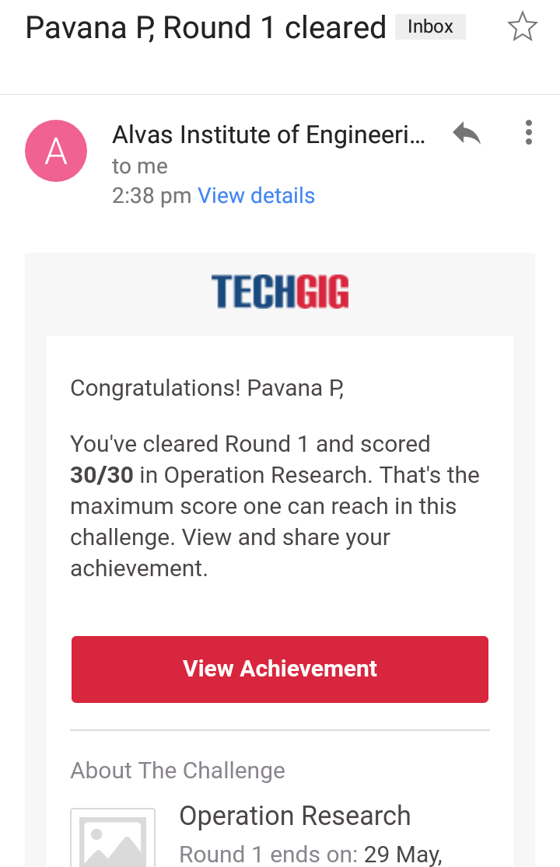Subject:-OR

**Certification Course Details:**

**Introduction to Ethical Hacking:**

Today I have completed these topics:

1.Ethical hacking in network Architecture Demonstration.

2.Ethical hacking in web applications.

.

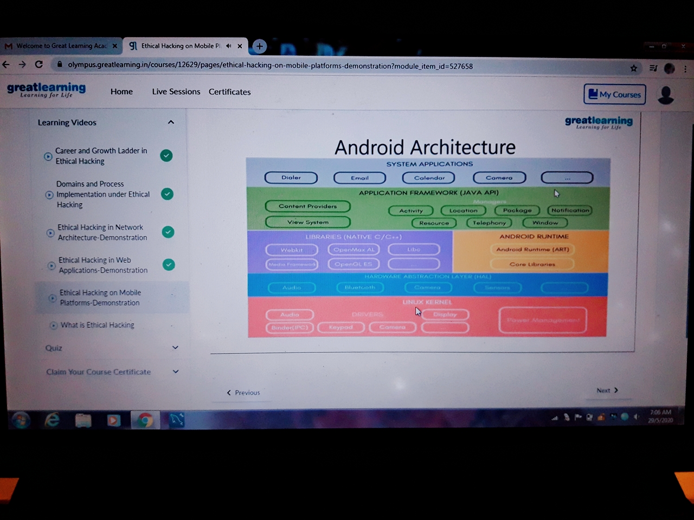

**Coding Challenges Details:**

**https://github.com/pavana-p-kulal/DAILY-STATUS/tree/master/29-5-20/Online%20Coding**